# FINANCIAL BANK LOAN

1.TOTAL LOAN APPLICATIONS:

SELECT COUNT(ID) AS TOTAL_LOAN_APPLICATION FROM financial_loan

MTD:

SELECT COUNT(ID) AS MTD_TOTAL_LOAN_APPLICATION FROM financial_loan

WHERE MONTH(ISSUE_DATE) = 12 AND YEAR(ISSUE_DATE) =2021



MOM:

--PMTD--

SELECT SUM(LOAN_AMOUNT) AS PMTD_TOTAL_FUNDED_AMOUNT FROM FINANCIAL_LOAN

WHERE MONTH(ISSUE_DATE) = 11 AND YEAR(ISSUE_DATE) = 2021

--MOM--

SELECT ((MTD_TOTAL_FUNDED_AMOUNT - PTMD_TOTAL_FUNDED_AMOUNT) * 1.0 / PTMD_TOTAL_FUNDED_AMOUNT) * 100 AS MOM_TOTAL_FUNDED_AMOUNT

FROM (

SELECT

SUM(CASE WHEN MONTH(ISSUE_DATE) =12 AND YEAR(ISSUE_DATE) =2021 THEN loan_amount END) AS MTD_TOTAL_FUNDED_AMOUNT,

SUM(CASE WHEN MONTH(ISSUE_DATE) = 11 AND YEAR(ISSUE_DATE) = 2021 THEN loan_amount END) AS PTMD_TOTAL_FUNDED_AMOUNT

FROM financial_loan

) AS LoanData;



2. TOTAL RECEIVED AMOUNT:

SELECT SUM(TOTAL_PAYMENT) AS TOTAL_RECEIVED_AMOUNT FROM financial_loan



MTD:

SELECT SUM(TOTAL_PAYMENT) AS MTD_TOTAL_RECEIVED_AMOUNT FROM FINANCIAL_LOAN

WHERE MONTH(ISSUE_DATE) = 12 AND YEAR(ISSUE_DATE) = 2021

MOM:

--PMTD--

SELECT SUM(TOTAL_PAYMENT) AS PMTD_TOTAL_RECEIVED_AMOUNT FROM FINANCIAL_LOAN

WHERE MONTH(ISSUE_DATE) = 11 AND YEAR(ISSUE_DATE) = 2021

--MOM--

SELECT ((MTD_TOTAL_RECEIVED_AMOUNT - PTMD_TOTAL_RECEIVED_AMOUNT) * 1.0 / PTMD_TOTAL_RECEIVED_AMOUNT) * 100 AS MOM_TOTAL_RECEIVED_AMOUNT

FROM (

SELECT

SUM(CASE WHEN MONTH(ISSUE_DATE) =12 AND YEAR(ISSUE_DATE) =2021 THEN TOTAL_PAYMENT END) AS MTD_TOTAL_RECEIVED_AMOUNT,

SUM(CASE WHEN MONTH(ISSUE_DATE) = 11 AND YEAR(ISSUE_DATE) = 2021 THEN TOTAL_PAYMENT END) AS PTMD_TOTAL_RECEIVED_AMOUNT

FROM financial_loan

) AS LoanData;



3.TOTAL FUNDED AMOUNT: MTD

SELECT SUM(LOAN_AMOUNT) AS TOTAL_FUNDED_AMOUNT FROM FINANCIAL_LOAN



MTD:

SELECT SUM(LOAN_AMOUNT) AS MTD_TOTAL_FUNDED_AMOUNT FROM FINANCIAL_LOAN

WHERE MONTH(ISSUE_DATE) = 12 AND YEAR(ISSUE_DATE) = 2021



MOM:

--PMTD--

SELECT SUM(LOAN_AMOUNT) AS PMTD_TOTAL_FUNDED_AMOUNT FROM FINANCIAL_LOAN

WHERE MONTH(ISSUE_DATE) = 11 AND YEAR(ISSUE_DATE) = 2021

--MOM--

SELECT ((MTD_TOTAL_FUNDED_AMOUNT - PTMD_TOTAL_FUNDED_AMOUNT) * 1.0 / PTMD_TOTAL_FUNDED_AMOUNT) * 100 AS MOM_TOTAL_FUNDED_AMOUNT

FROM (

SELECT

SUM(CASE WHEN MONTH(ISSUE_DATE) =12 AND YEAR(ISSUE_DATE) =2021 THEN loan_amount END) AS MTD_TOTAL_FUNDED_AMOUNT,

SUM(CASE WHEN MONTH(ISSUE_DATE) = 11 AND YEAR(ISSUE_DATE) = 2021 THEN loan_amount END) AS PTMD_TOTAL_FUNDED_AMOUNT

FROM financial_loan

) AS LoanData;



4.AVERAGE DTI:

SELECT AVG(DTI)*100 AS AVERAGE_DTI FROM financial_loan



MTD:

select AVG(DTI)*100 AS MTD_AVERAGE_DTI FROM FINANCIAL_LOAN

WHERE MONTH(ISSUE_DATE) = 12 AND YEAR(ISSUE_DATE) = 2021

MOM:

--PMTD--

SELECT AVG(DTI)*100 AS PMTD_AVERAGE_DTI FROM FINANCIAL_LOAN

WHERE MONTH(ISSUE_DATE) = 11 AND YEAR(ISSUE_DATE) = 2021

--MOM--

SELECT ((MTD_AVERAGE_DTI - PTMD_AVERAGE_DTI) * 1.0 / PTMD_AVERAGE_DTI) * 100 AS MOM_AVERAGE_DTI

FROM (

SELECT

AVG(CASE WHEN MONTH(ISSUE_DATE) =12 AND YEAR(ISSUE_DATE) =2021 THEN DTI END) AS MTD_AVERAGE_DTI,

AVG(CASE WHEN MONTH(ISSUE_DATE) = 11 AND YEAR(ISSUE_DATE) = 2021 THEN DTI END) AS PTMD_AVERAGE_DTI

FROM financial_loan

) AS LoanData;



5. AVERAGE INTEREST RATE:

SELECT AVG(INT_RATE)*100 AS AVERAGE_INTEREST_RATE FROM FINANCIAL_LOAN



MTD:

select AVG(INT_RATE)*100 AS MTD_AVERAGE_INT_RATE FROM FINANCIAL_LOAN

WHERE MONTH(ISSUE_DATE) = 12 AND YEAR(ISSUE_DATE) = 2021

MOM:

--MOM--

SELECT ((MTD_AVERAGE_INT_RATE - PTMD_AVERAGE_INT_RATE) * 1.0 / PTMD_AVERAGE_INT_RATE) * 100 AS MOM_AVERAGE_INT_RATE

FROM (

SELECT

AVG(CASE WHEN MONTH(ISSUE_DATE) =12 AND YEAR(ISSUE_DATE) =2021 THEN INT_RATE END) AS MTD_AVERAGE_INT_RATE,

AVG(CASE WHEN MONTH(ISSUE_DATE) = 11 AND YEAR(ISSUE_DATE) = 2021 THEN INT_RATE END) AS PTMD_AVERAGE_INT_RATE

FROM financial_loan

) AS LoanData;



GOOD LOANS APPLICATION:

SELECT COUNT(ID) AS GOOD_lOAN_APPLICATION FROM FINANCIAL_LOAN

WHERE LOAN_STATUS = 'FULLY PAID' OR LOAN_STATUS = 'CURRENT'



GOOD LOANS RECEIVED AMOUNT;

SELECT SUM(TOTAL_PAYMENT) AS GOOD_RECEIVED_AMOUNT FROM financial_loan

WHERE LOAN_STATUS = 'FULLY PAID' OR LOAN_STATUS = 'CURRENT'

GOOD LOAN FUNDED AMOUNT:

SELECT SUM(loan_amount) AS GOOD_LOAN_FUNDED_AMOUNT FROM financial_loan

WHERE LOAN_STATUS = 'FULLY PAID' OR LOAN_STATUS = 'CURRENT'



BAD LOAN APPLICATION:

SELECT COUNT(ID) AS BAD_LOAN_APPLICATION FROM FINANCIAL_LOAN

WHERE LOAN_STATUS = 'CHARGED OFF'



BAD LOAN RECEIVED AMOUNT:

SELECT SUM(TOTAL_PAYMENT) AS BAD_LOAN_RECEIVED_AMOUNT FROM FINANCIAL_LOAN

WHERE LOAN_STATUS = 'CHARGED OFF'

BAD LOAN FUNDED AMOUNT:

SELECT SUM(loan_amount) AS BAD_LOAN_FUNDED_AMOUNT FROM financial_loan

WHERE LOAN_STATUS = 'CHARGED OFF'



LOAN STATUS GRID:

SELECT LOAN_STATUS,

COUNT(ID) AS TOTAL_LOAN_APPLICATION,

SUM(TOTAL_PAYMENT) AS TOTAL_RECEIVED_AMOUNT,

SUM(LOAN_AMOUNT) AS TOTAL_FUNDED_AMOUNT,

AVG(DTI)*100 AS AVERAGE_DTI,

AVG(INT_RATE) AS AVERAGE_INT_RATE

FROM FINANCIAL_LOAN

GROUP BY LOAN_STATUS



MONTHLY TRENDS:

SELECT DATENAME(MONTH,ISSUE_DATE) AS MONTH,

COUNT(ID) AS TOTAL_LOAN_APPLICATION ,

SUM(TOTAL_PAYMENT) AS TOTAL_RECEIVED_AMOUNT,

SUM(LOAN_AMOUNT) AS TOTAL_FUNDED_AMOUNT,

AVG(DTI)*100 AS AVERAGE_DTI,

AVG(INT_RATE) AS AVERAGE_INT_RATE

FROM FINANCIAL_LOAN

GROUP BY DATENAME(MONTH ,ISSUE_DATE)

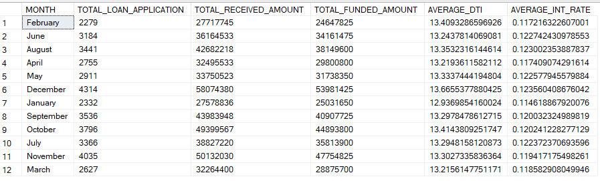

LONG TERM:

SELECT TERM AS LONG_TERM,

COUNT(ID) AS TOTAL_LOAN_APPLICATION ,

SUM(TOTAL_PAYMENT) AS TOTAL_RECEIVED_AMOUNT,

SUM(LOAN_AMOUNT) AS TOTAL_FUNDED_AMOUNT,

AVG(DTI)*100 AS AVERAGE_DTI,

AVG(INT_RATE) AS AVERAGE_INT_RATE

FROM FINANCIAL_LOAN

GROUP BY TERM

REGIONAL ANALYSIS:

SELECT address_state AS REGION_STATE,

COUNT(ID) AS TOTAL_LOAN_APPLICATION ,

SUM(TOTAL_PAYMENT) AS TOTAL_RECEIVED_AMOUNT,

SUM(LOAN_AMOUNT) AS TOTAL_FUNDED_AMOUNT,

AVG(DTI)*100 AS AVERAGE_DTI,

AVG(INT_RATE) AS AVERAGE_INT_RATE

FROM FINANCIAL_LOAN

GROUP BY address_state

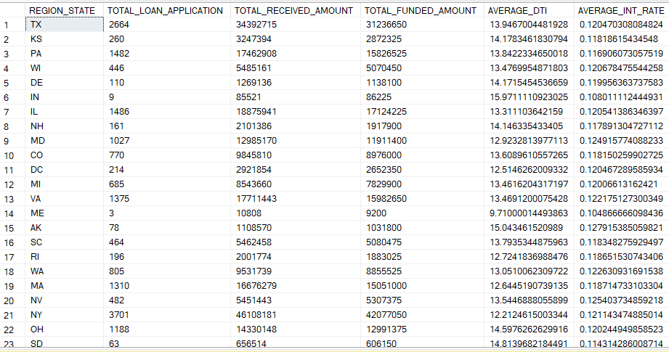

PURPOSE BREAKDOWN:

SELECT PURPOSE AS PURPOSE,

COUNT(ID) AS TOTAL_LOAN_APPLICATION ,

SUM(TOTAL_PAYMENT) AS TOTAL_RECEIVED_AMOUNT,

SUM(LOAN_AMOUNT) AS TOTAL_FUNDED_AMOUNT,

AVG(DTI)*100 AS AVERAGE_DTI,

AVG(INT_RATE) AS AVERAGE_INT_RATE

FROM FINANCIAL_LOAN

GROUP BY purpose

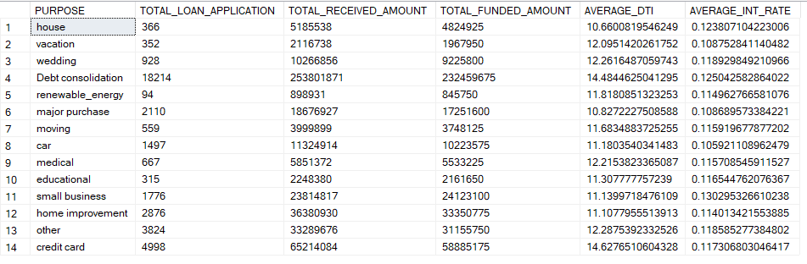

EMPLOYEE_ LENGTH:

SELECT emp_length AS EMP_LENGTH,

COUNT(ID) AS TOTAL_LOAN_APPLICATION ,

SUM(TOTAL_PAYMENT) AS TOTAL_RECEIVED_AMOUNT,

SUM(LOAN_AMOUNT) AS TOTAL_FUNDED_AMOUNT,

AVG(DTI)*100 AS AVERAGE_DTI,

AVG(INT_RATE) AS AVERAGE_INT_RATE

FROM FINANCIAL_LOAN

GROUP BY emp_length

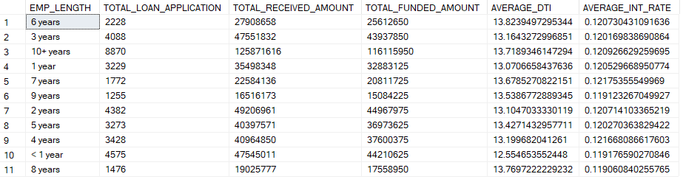

HOME OWNERSHIP BREAKDOWN:

SELECT home_ownership AS home_ownership,

COUNT(ID) AS TOTAL_LOAN_APPLICATION ,

SUM(TOTAL_PAYMENT) AS TOTAL_RECEIVED_AMOUNT,

SUM(LOAN_AMOUNT) AS TOTAL_FUNDED_AMOUNT,

AVG(DTI)*100 AS AVERAGE_DTI,

AVG(INT_RATE) AS AVERAGE_INT_RATE

FROM FINANCIAL_LOAN

GROUP BY home_ownership

